NEWBRIDGE SCHOOL – YSGOL TRECELYN
The ‘MyEd’ School App

Here are the instructions for downloading the new ‘MyED’ school app and using the app to access a wide range of school information, as well as parent pay, Class Charts and SIMS ID.

- Type ‘MyEd’ into the search engine in the app store of your smart phone or device.

- Select the MyEd app from the list and download it to your device. There is no charge to install this app.

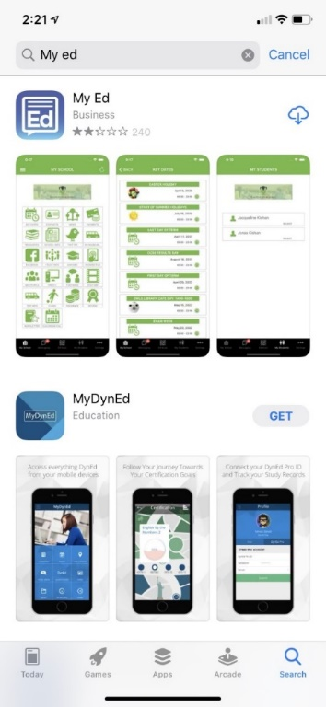

- Open the app once it has been installed. Select to allow the app to send you push notifications. This will then give you a notification whenever you are sent correspondence from the school.

- You will be asked to enter the name of a school or its postcode. Type in ‘Newbridge’ or ‘NP11 5FR’ into the search bar and then select Newbridge School from the listed schools.

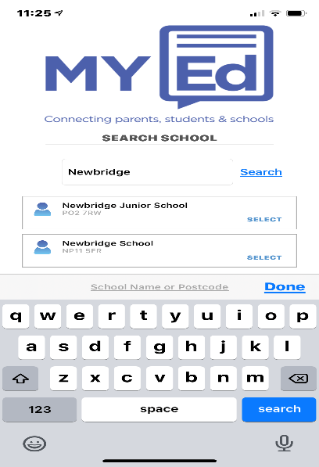

- You will be prompted to enter your name, mobile number and E-Mail address into the required fields.

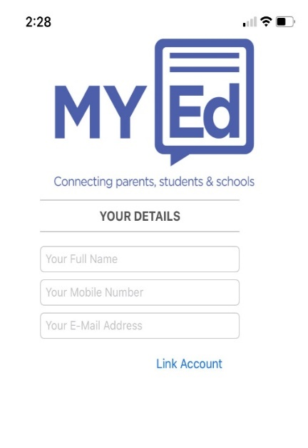

The mobile phone number and e-mail address must be the same as those you have already provided to us for communication purposes. If these details do not match, the app will still work however you will not have access to the information about your child.

- The ‘MyEd’ app send a text message to the mobile phone number you have registered. Containing a security code that is needed to verify your identity to access the MyEd app. Enter this code into the required field.

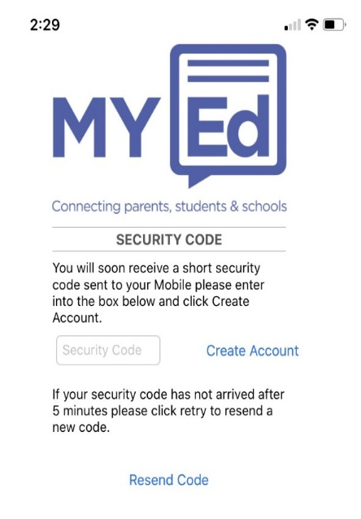

Please note it can take up to 5 minutes to receive this text message. If after 5 minutes you have still not received your code you can ask for the app to resend the code.

- Once logged in, you will be directed to the main MyEd dashboard. From here you can access information about your child, contact the school regarding pupil absences and click onto the various school links - each containing relevant information to support you, as a parent, in your child’s education.
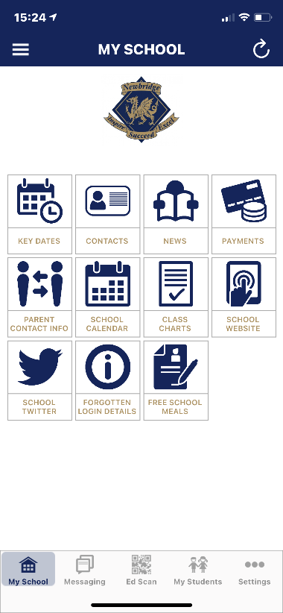
Various school links (details of each link on next page)

Here you access attendance and absence information about your child
Here you can message the school about pupil absences
 | This section contains a list of the key dates of upcoming school events from the school calendar, such as school INSET days, school holidays and parents evenings.
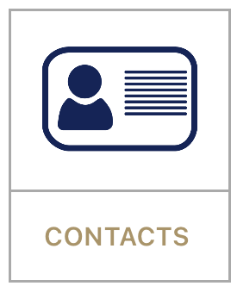 | This section contains the contact details of the main school reception and key staff within the school, including attendance officer, examinations officer, progress leaders, heads of department and the senior management team.
 | This section contains key news and information from the school, including parent newsletters, information about examinations, and details of school closures
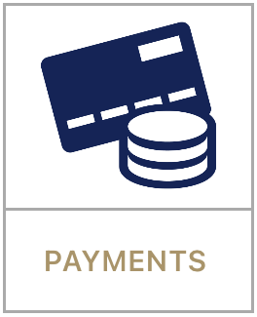 | This section takes you to ParentPay - the system that we use in school for collecting payments for school trips and putting money onto pupils’ accounts for use in the canteen. You will need to enter your ParentPay login details (issued separately) the first time you access your account from the MyEd dashboard.
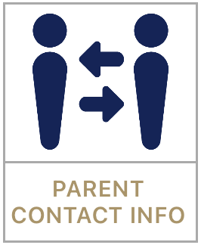 | This section takes you to SIMS ID app. This app enables parents to update contact information online. The app then sends this information back to school and our records automatically update.  You will need to enter your login details (issued separately) the first time you access this app from the MyEd dashboard.
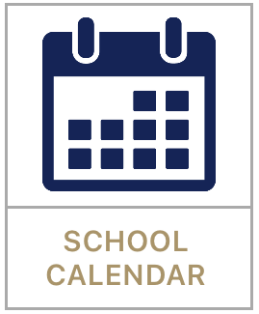 | This section takes you to the public school calendar. The calendar contains the dates and times of key events throughout the year, including term times, INSET days, holidays, parents evenings and school events and trips.
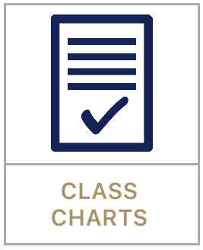 | This section takes you to the Class Charts Parent app. This app provides up to date reports on attendance and absences, homework, and detentions.  You will need to enter your login details (issued separately) the first time you access this app from the MyEd dashboard.
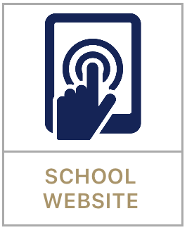 | This section provides a direct link to the school’s website http://learn.caerphilly.org.uk/newbridgeschool. The website contains all of the key information relating to the school, including information about our staffing and curriculum, key school policies, newsletters and key messages from the headteacher.
 | This section provides a direct link to the school’s main twitter account, @NewbridgeSch, which is frequently updated about school news and events as they happen.
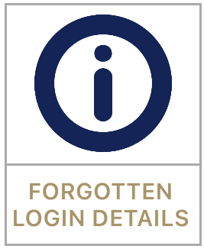 | This section contains the details of who you need to contact at the school should you either forget your login details or are if you are having problems logging into one of the apps from the MyEd dashboard.
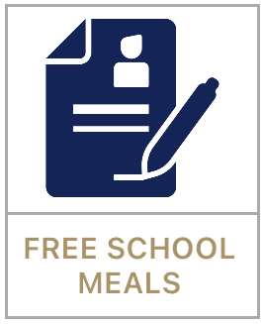 | This section provides a direct link to the Free School Meals section of Caerphilly’s local authority website. The site provides information about being eligible for Free School Meals, as well as a link to the application form to apply for Free School Meals.

